**Module Assignment**

**Module 10**

**QMB-6304 Analytical Methods for Business**

1. Maggie’s Pottery Barn is a mid-sized pottery shop selling handmade pottery to tourists in Cherokee, North Carolina. Seven products of interest are 1) standard clay mugs, 2) wolf mugs, 3) cat mugs, 4) right-handed hand warmer mugs, 5) left-handed hand warmer mugs, 6) clay serving trays, and 7) 10-inch clay bowls. (Some of these products are shown in the embedded document below.) The products are made and fired in Maggie’s shop where tourists can watch, and then sold to tourists in a showroom. Maggie’s currently has 27 full-time employees working 8 hours each day for 22 days per month. Employees are paid $12 per hour. For the current month Maggie’s has 6 tons of clay, costing $0.80 per pound. Revenue and other details for each product are given in the table below. 

|  |  |  |  |  |  |  |  |
| --- | --- | --- | --- | --- | --- | --- | --- |
|  | 10-in. Bowl | Standard Mug | Wolf Mug | Cat  Mug | RH Warmer | LH Warmer | Serving Tray |
| Retail  Price/Unit | $80 | $28 | $35 | $40 | $35 | $35 | $90 |
| Clay lbs. Needed | 4 | 1 | 1 | 1 | 1 | 1 | 3 |
| Labor Hrs.  Needed | 1 | 1 | 1.7 | 2.3 | 2 | 2 | 1 |
| Overhead Cost/Unit | $3 | $3 | $3 | $3 | $3 | $3 | $3 |

Formulate and solve the math optimization model which will maximize overall profit by determining the mix of the seven products to be produced this month. Maggie’s has certain other restrictions which must be reflected in your solution. These are:

1. At most 2000 mugs in total (combined for all types of mugs) can be sold.
2. At least 5% of all hand warming mugs produced must be left-handed mugs.
3. At most 15% of all hand warming mugs produced can be left-handed mugs.
4. At least 350 hand warming mugs of both types should be produced.
5. The number of wolf mugs produced must be greater than or equal to the number of cat mugs produced.
6. The number of standard mugs produced must be equal to or greater than the total number of wolf mugs and cat mugs combined.
7. The number of bowls produced must be equal to or greater than the number of serving trays
8. The number of bowls cannot exceed 400.
9. 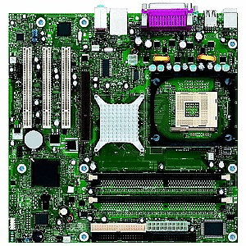BP Computer Services assembles its own brand of personal computers from component parts it purchases overseas and domestically. BP has enough regular production capacity to produce up to 2000 computers per week. It can produce an additional 300 computers with overtime. Also, an additional 500 computers per week can be sourced through a subcontractor. The cost of assembling, inspecting, and packaging a computer during regular time is $190. Overtime production of a computer costs $220, and subcontracting has a unit cost of $230. Further, it costs $40 per computer per week to hold a computer in inventory for future delivery, but BP’s storage facility can store a maximum of only 1500 computers. BP wants to meet all customer orders with no shortages to provide quality service. BP’s confirmed orders for the next six weeks are given below.

|  |  |  |  |  |  |  |
| --- | --- | --- | --- | --- | --- | --- |
| Week | 1 | 2 | 3 | 4 | 5 | 6 |
| Unit Orders | 1800 | 2600 | 2800 | 2900 | 1200 | 3300 |

1. Determine the least cost master production schedule and inventory plan for BP given the availability of regular and overtime production and inventory storage.
2. During the six-week planning horizon, what is the maximum and minimum inventory levels your model plans for BP’s storage facility?
3. 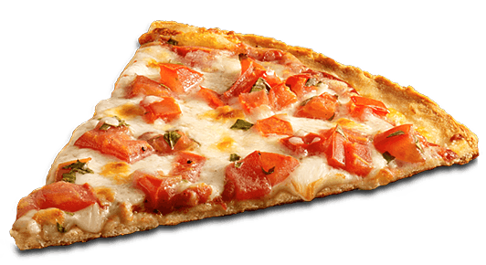Al Forno is a local pizza restaurant that is participating in an upcoming Italian Heritage festival this Saturday. At the festival Al Forno will have a small tent and be selling slices of pizza to festival attendees. Al Forno will donate all revenues to the charitable organization putting on the festival. On this occasion Al Forno’s owners know that any kind of pizza offered will sell. Al Forno will offer plain, meat, vegetable, and supreme pizzas for sale by the slice at the festival. Each variety has its own requirement for sauce, cheese, dough, and topings as shown in the table below. Each variety has its own selling price per slice. To maximize its charitable donation Al Forno wishes to maximize revenues from sales of slices of pizza.

|  |  |  |  |  |  |
| --- | --- | --- | --- | --- | --- |
|  | Cheese | Meat | Vegetable | Supreme | Available |
| Dough (oz.) | 5 | 5 | 5 | 5 | 300 lbs. |
| Sauce (fl. oz.) | 3 | 3 | 3 | 3 | 20 gallons |
| Cheese (oz.) | 4 | 3 | 3 | 4 | 250 lbs. |
| Meat (oz.) | 0 | 3 | 0 | 2 | 90 lbs. |
| Vegetables (oz.) | 0 | - | 3 | 2 | 75 lbs. |
| Price/Slice | $5 | $8 | $6 | $9 |  |

1. Formulate and solve the linear programming model which will determine the mix of pizza types to maximize revenue. Make sure your model produces at least 100 slices of each type of pizza. Also make sure that the combined number of slices of Cheese, Meat, and Vegetable pizza is at least 75% of the total number of pizza slices produced of all flavors.

|  |
| --- |
| Image result for chevy vega dragster |
| Buster Bocelli on a delivery in the Fornomobile. |

1. Al Forno employee Buster Bocelli can be ready at main restaurant to bring more of any ingredients required to make more pizza slices and increase revenue. He’ll deliver them to the festival quickly in the restaurant’s delivery vehicle, the Fornomobile. According to your model which ingredient(s) would be immediately required to increase revenue?

**Instructions:** Your deliverable will be a functioning Excel spreadsheet with each problem on a separate worksheet page. The opening worksheet page of your Excel file will be a cover page with your name. For each problem a fully populated Solver dialog box will be available and your model should solve in a test by the instructor. The deliverable will be uploaded to Canvas by the assignment deadline.